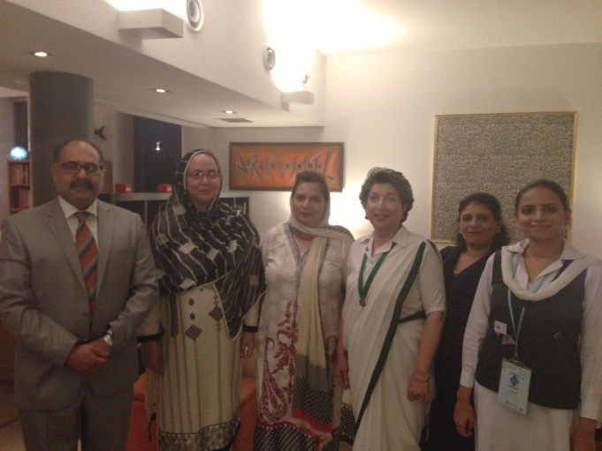
Tokyo (July 6, 2013) – 11th Asia Pacific Regional Conference was held in Tokyo from 29 June to 6 July 2013, hosted by Girls Scouts of Japan (Girls Guide).
A delegation from Pakistan headed by Ms. Farhana Azim, National Commissioner, Pakistan Girls Guide Association participated along with Dr. Talat Imtiaz, Minister Economic of Pakistan Embassy.
The delegation highlighted the history, movement and work of the Girls Guide in Pakistan and underlined the importance of girls and women empowerment in Pakistani society. The delegation also called on the Ambassador.

